THE COMPLETE HISTORY OF CANDYMAN

Fierce, intricate urban horror documentary, chronicling Clive Barker’s Candyman franchise from The Forbidden to Jordan Peele’s reboot, starring horror legend Tony Todd, on digital Halloween 2021
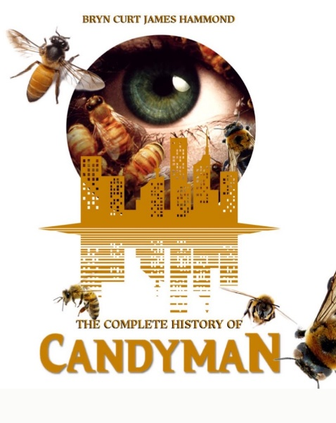
Featuring Shawn C. Phillips (Ghost Shark, Zombi VIII: Urban Decay)
Dallas Jackson (Thriller, Welcome to Sudden Death)
Robin Nassif (Warlock III: The End of Innocence, Halloween: Resurrection)
Robin Pierce (Starburst Magazine)

The Complete History of Candyman begins with a modest overview of the heyday of the horror genre and its sharp decline, solely down to the responsibility of the decay of the slasher sub-genre, when all of Hollywood, from the sleaziest independent backstreet butcher to the highest-paid studio executive, was greenlighting any film that featured a masked psychopath, scores of 30 + something teenagers with a half decent set of lungs, an ample array of ways to die and, in the best of both worlds, all three.
It’s succinct view tours through Hollywood’s changing landscape and horror’s renaissance, during which the horror genre returned to producing critically and commercially successful horror films, much as it did during the era known as the Golden Age of slashers, which peaked between 1978 and 1984.
Candyman History comes full circle by analysing the symbiotic relationship between the horror genre and the African-American experience, and how Spike Lee’s masterpiece, Do the Right Thing, became the bracing model for how the studio system packaged contemporary racial issues in a manner that startlingly respects the ability of viewers to think for themselves, leading to the birth of Bernard Rose’s Candyman; the two are inextricably linked, and its sequels.

Written and directed by bestselling author Bryn Curt James Hammond (A Case for Murder Brittany Murphy Files, The Complete History of The Howling), The Complete History of Candyman delves into the original trilogy that ran from 1992 to 1999, based on the short story The Forbidden by Clive Barker, that by turns utilised the embodiment of fearmongering seen in Do the Right Thing, but by turning it into a literal bogeyman in the deprived Cabrini-Green area of Chicago. It uses elements of social criticism and the great rot of social housing, while posing the question “Does God exist?”, all through the eyes of the film’s protagonist, which allows the viewers a bizarre tour de force of the harsh reality that results when stereotypes applied to black people are believed en masse.

The Complete History of Candyman presents an in-depth investigation into the series, the author and the up-and-coming Jordan Peele reboot from brand new and archival interviews from scholars and creators, from the voices who survived the genre’s past trends to those shaping its future.

“We have brought together extremely strong-minded talent to discuss the ground breaking Bernard Rose classic and its sequels. For me the original is nothing less than a celluloid art piece, a canvas painted in an elaborate moody, red, black and brown colour palette not to dissimilar to a scheme typical of European films, of a campfire with enduring articulation of style – a gift that keeps on giving with every re-watch,” said Bryn, a pop culture scholar and novelist who specializes in the True Crime genre and all things celebrity.
“Candyman’s underlining current of fear readily allows its viewer to confront social issues, from both an urbanized village of enclosed repression to the supernatural encounters. The series also has a running theme Farwell to the Flesh and in-part Day of the Dead; all possess the same strange, dream logic, history wrenching itself into the present, and an insistence on asking difficult questions about American racism, the latter predominantly challenging family lore, the traumas of national history, ancestral relationships to Candyman, a plantation slave, which all point to the racism at America’s foundation. I leave no stone unturned, and that includes the author’s own legal woes that derailed his winning streak in Hollywood, which is so often overlooked.”

Released on digital Halloween 2021

Contact: Keith Taylor – miamifoxtalent@gmail.com

